Order Of Service

Singing: Psalm 51b—CW page 87

Reading: Psalm 109

Opening Hymn: CW 260

Reading: Acts 27:13-20

Request Hymn: CW Supplement 735

Reading: Matthew 12:38-42

Sermon Hymn: CW 363

Sermon Text: Mark 12:1-12

Question And Answer

Prayer

The Apostles’ Creed, TLH page 12

Holy Communion

The Lord's Prayer

The Blessing

Closing Hymn: CW 245

* * * * * * * * * * *

Koinonia Hour

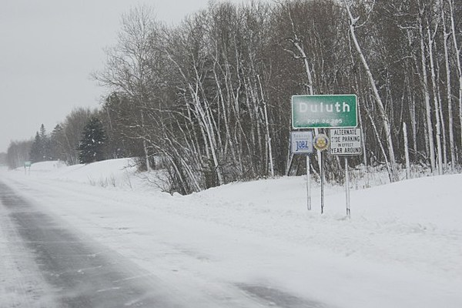

Winter In Duluth, MN

Water
Of
Life

12 January 2020

W A T E R O F L I F E

Independent Christian Church—Conservative Lutheran Doctrine

Worship Service: 9:30 a.m. Bible Study: 10:45 a.m.

Larry Cooper, Pastor E-Mail address:
111 N. Ridge Road lcooper@wateroflife.cc
Coon Valley, WI 54623 Web Site:
www.wateroflife.cc

* * * * * * * * * * * * * * * * * * * * * * * * * * *

Sermon Text: Mark 12:1-12

Question And Answer

* * * * * * * * * * * * * * * * * * * * * * * * * * *

Mark 12:1 And he began to speak unto them by parables. A certain man planted a vineyard, and set an hedge about it, and digged a place for the winefat, and built a tower, and let it out to husbandmen, and went into a far country.
:2 And at the season he sent to the husbandmen a servant, that he might receive from the husbandmen of the fruit of the vineyard.
:3 And they caught him, and beat him, and sent him away empty.
:4 And again he sent unto them another servant; and at him they cast stones, and wounded him in the head, and sent him away shamefully handled.
:5 And again he sent another; and him they killed, and many others; beating some, and killing some.
:6 Having yet therefore one son, his wellbeloved, he sent him also last unto them, saying, They will reverence my son.
:7 But those husbandmen said among themselves, This is the heir; come, let us kill him, and the inheritance shall be ours.
:8 And they took him, and killed him, and cast him out of the vineyard.
:9 What shall therefore the lord of the vineyard do? he will come and destroy the husbandmen, and will give the vineyard unto others.
:10 And have ye not read this scripture; The stone which the builders rejected is become the head of the corner:
:11 This was the Lord's doing, and it is marvellous in our eyes?
:12 And they sought to lay hold on him, but feared the people: for they knew that he had spoken the parable against them: and they left him, and went their way.
____________

John 1:1 In the beginning was the Word, and the Word was with God, and the Word was God.
2 The same was in the beginning with God.
3 All things were made by him; and without him was not any thing made that was made.
4 In him was life; and the life was the light of men.
5 And the light shineth in darkness; and the darkness comprehended it not.
6 There was a man sent from God, whose name was John.
7 The same came for a witness, to bear witness of the Light, that all men through him might believe.
8 He was not that Light, but was sent to bear witness of that Light.
9 That was the true Light, which lighteth every man that cometh into the world.
10 He was in the world, and the world was made by him, and the world knew him not.
11 He came unto his own, and his own received him not.

